# INFOST 310-201​ ​–​ ​Assignment 3

# Prototype Development

## Website Name

ExploreBoldly

## User Main Task

The user will be booking a round trip flight from New York, NY to Miami, FL

## Site Mission

A comprehensive online travel resource center where you can discover destinations, book your transportation & lodging and plan your adventures.

## Target User Group

This site is designed to assist travelers of all types, from budget backpackers to big spenders by offering access to reliable content and trusted providers on an easy use, free platform.

## Description of Web Content

The site will include an index/home page with a navigation bar across the top linking to the site’s secondary pages. Each page will include a “table like” display of images and written descriptions about that location or activity, as well as a refine able subcategory search list anchored to the left side of the page.

All pages will have a similar font and color scheme to ensure continuity. Images and links with feature scroll-over highlights and additional information if applicable. Additionally, all pages will include an animated carousel display of popular items, featured content or current deals.

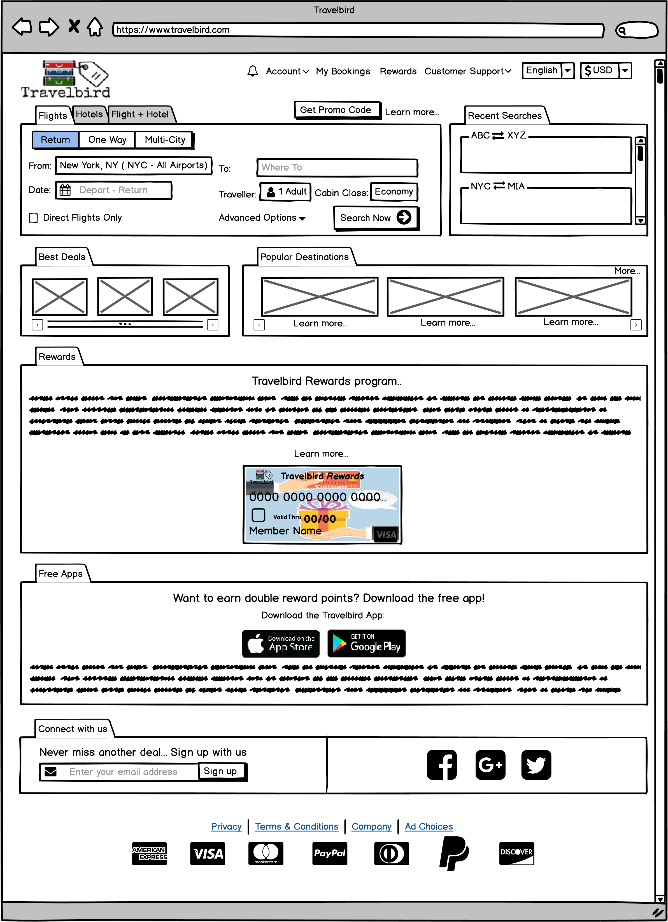



Links to learn more about the company, the standard legal statements and icons that represent accepted payment methods

**8**



Join the sites mailing list by entering an email address into the form and/or click the links to follow on various social media platforms.

**7**



Google Play and Apple Store links to download the mobile app as well as an explanation of features and basic functionality

**6**



Learn more about our rewards program here. Click “learn more” to move to the application screen.

**5**



A carousel view with toggle of our most popular destinations

**4**



A carousel with view with toggle of our current best deals.

**3**



Scroll down here to view a list of your of recent searches.



Select the type of search desired here (flight, hotel or flight and hotel). Each tab will produce different options in the form below.

**2**

**1**

**https://www.goboldly.com**

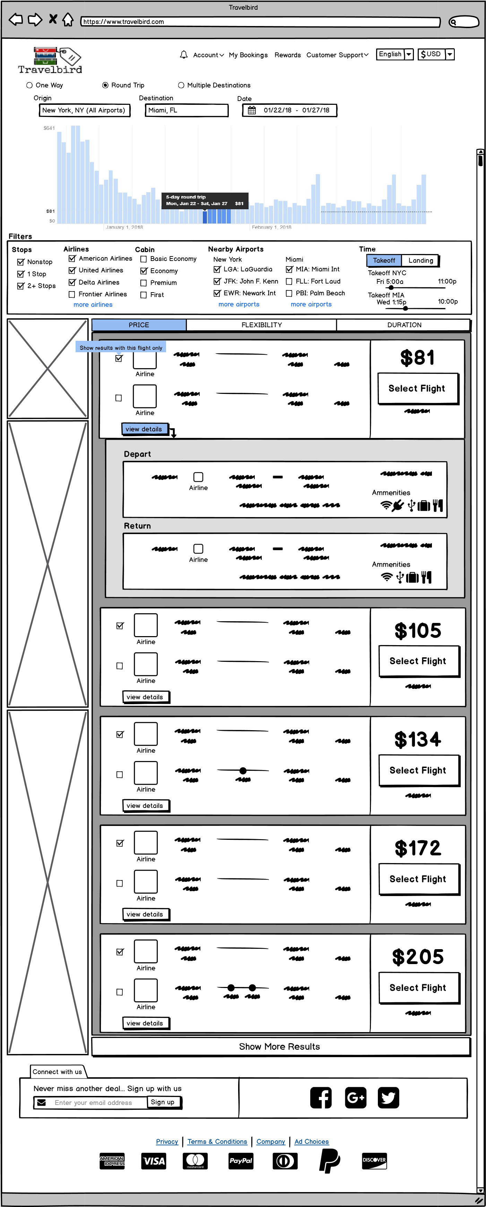



Click here to populate the list with more results

**6**



Click here to select a flight and move to the sign in / create an account screen.

**5**



View specific flight details in this expanding window which drops down from the main list option window.

**4**



Sort your search results by clicking one of the following header buttons (price, flexibility, duration)

**3**



Filter your basic search results here by checking the boxes in their corresponding categories.

**2**



By entering information into the origin, destination and date fields the system will generate a bar chart illustrating average prices in the months before and after your query.

**1**

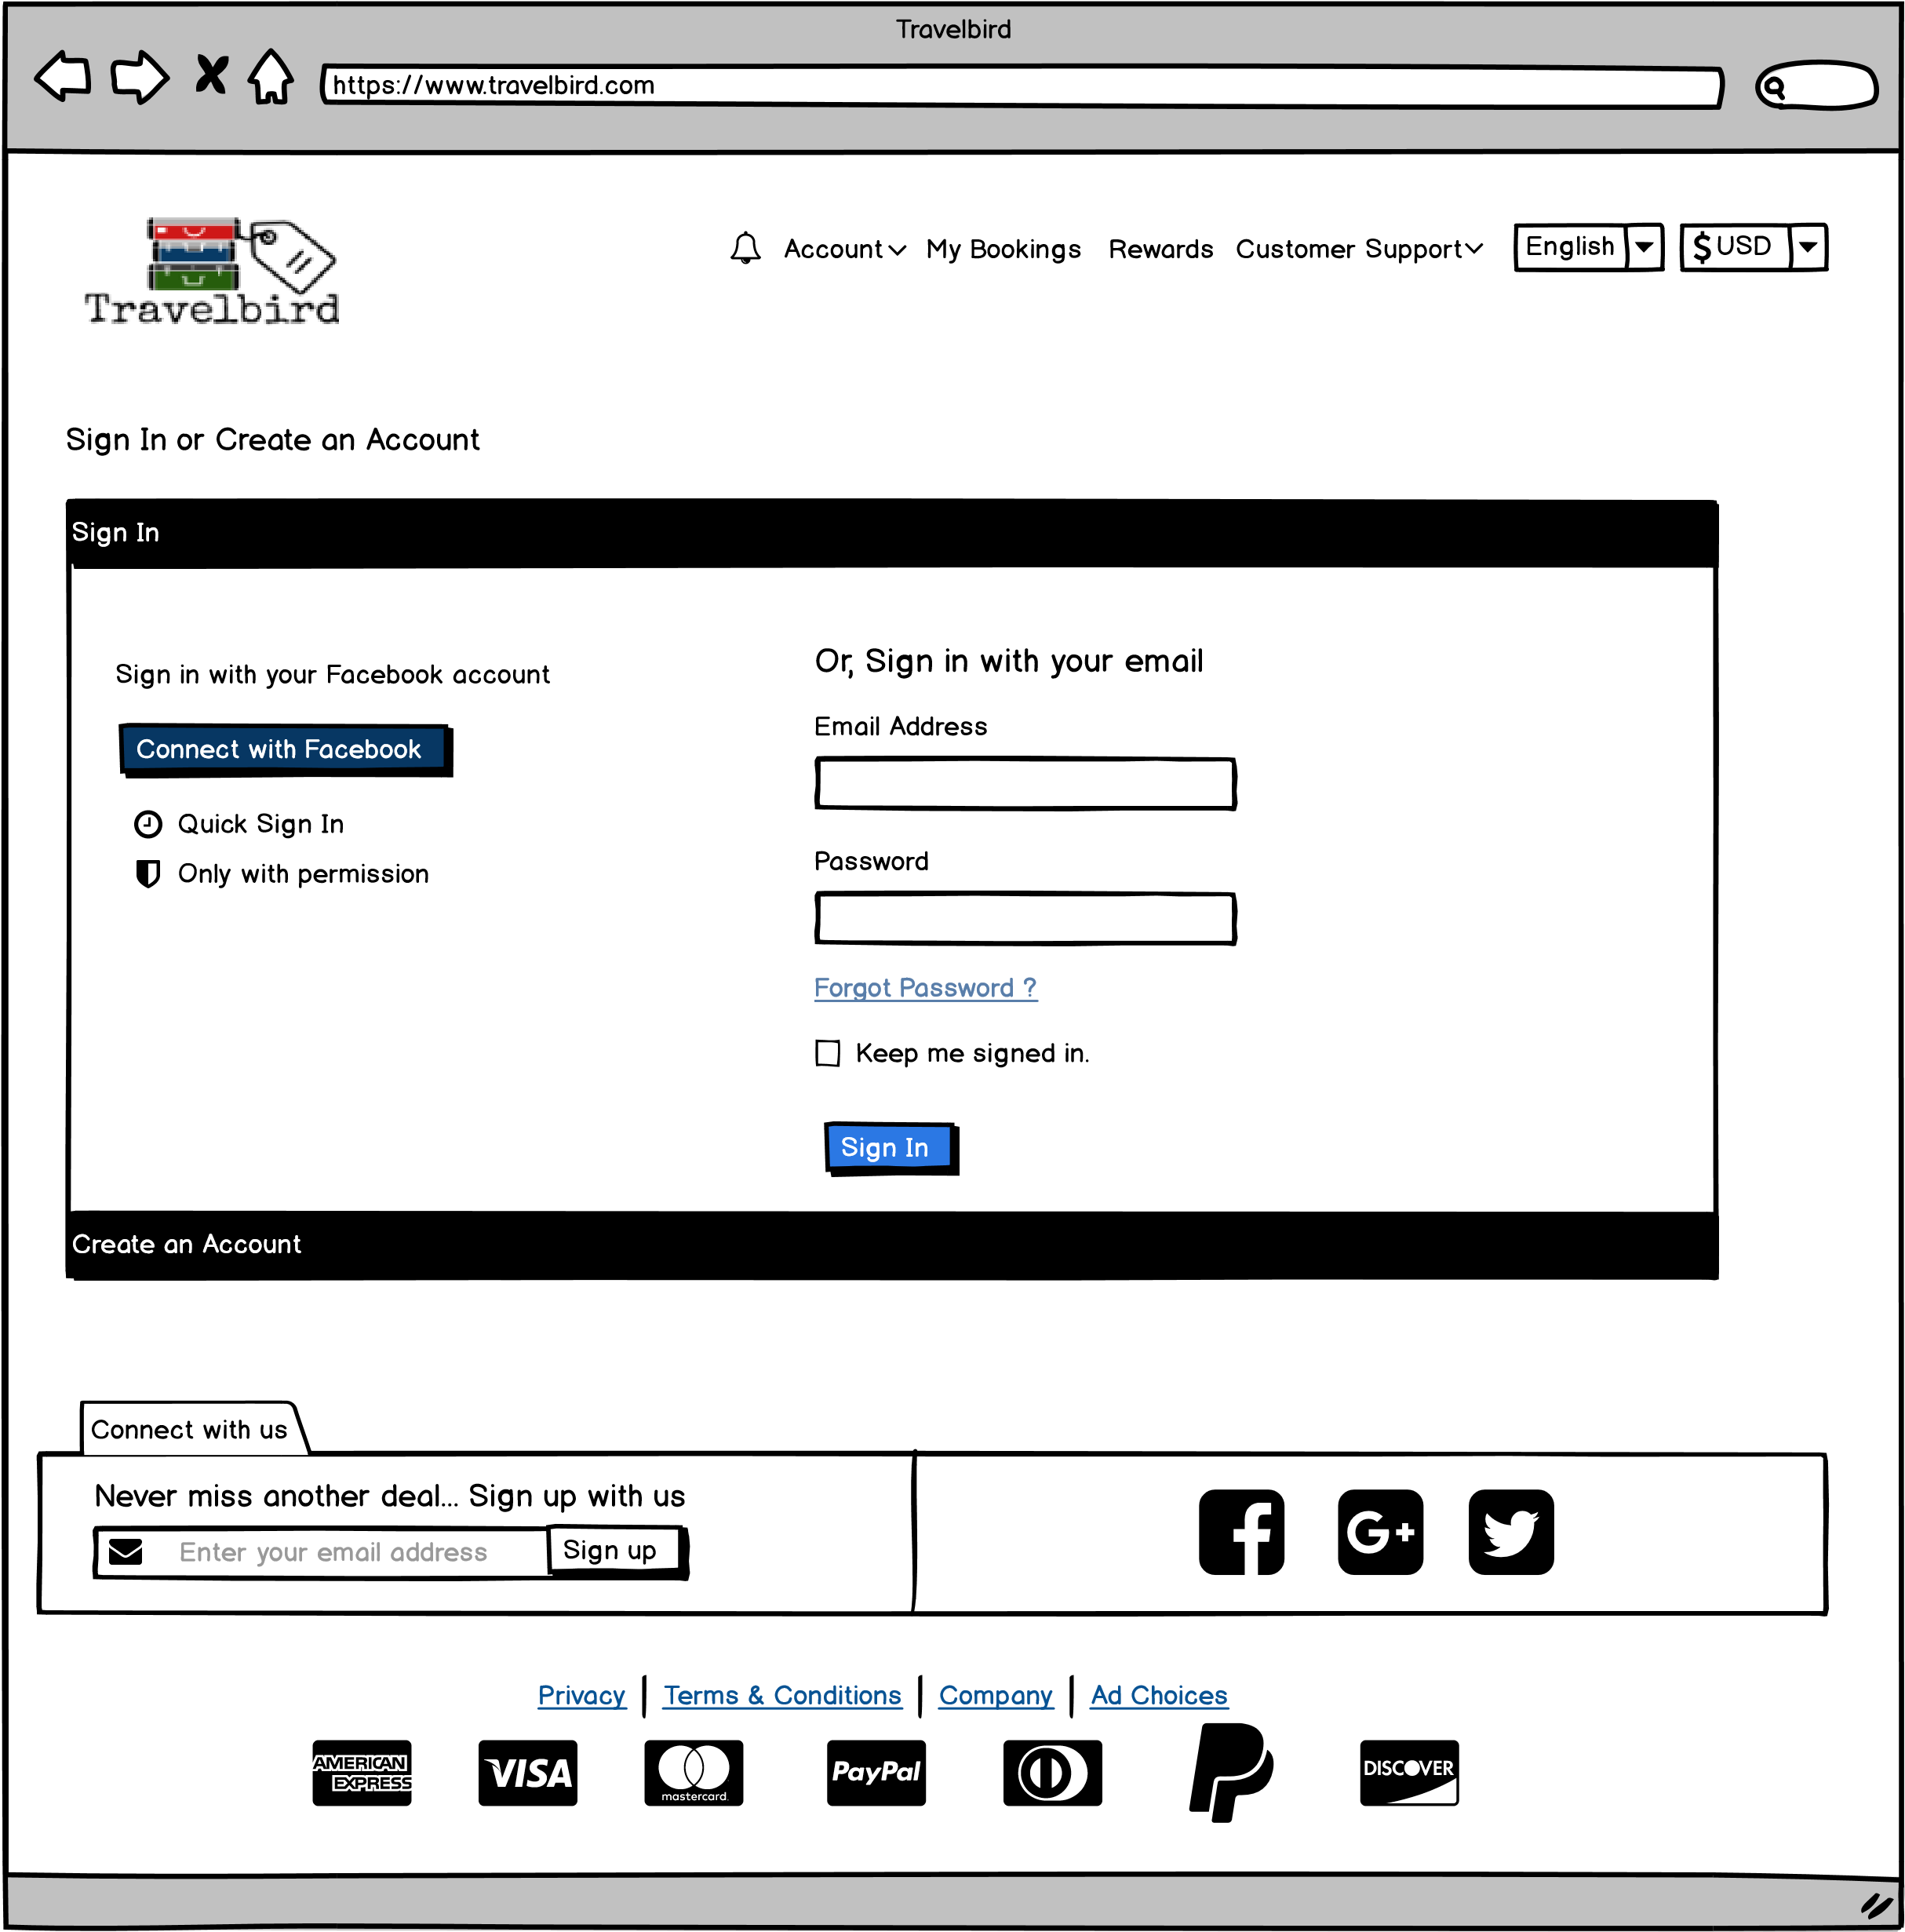

**https://www.goboldly.com**



Forgot password link that starts the password recovery process.

**3**



Click here to shrink the “sign in” pane and expand the “create an account” pane. (seen on next page)

**2**

**1**



Complete the form field and click “sign in” to move to then review and payment screen

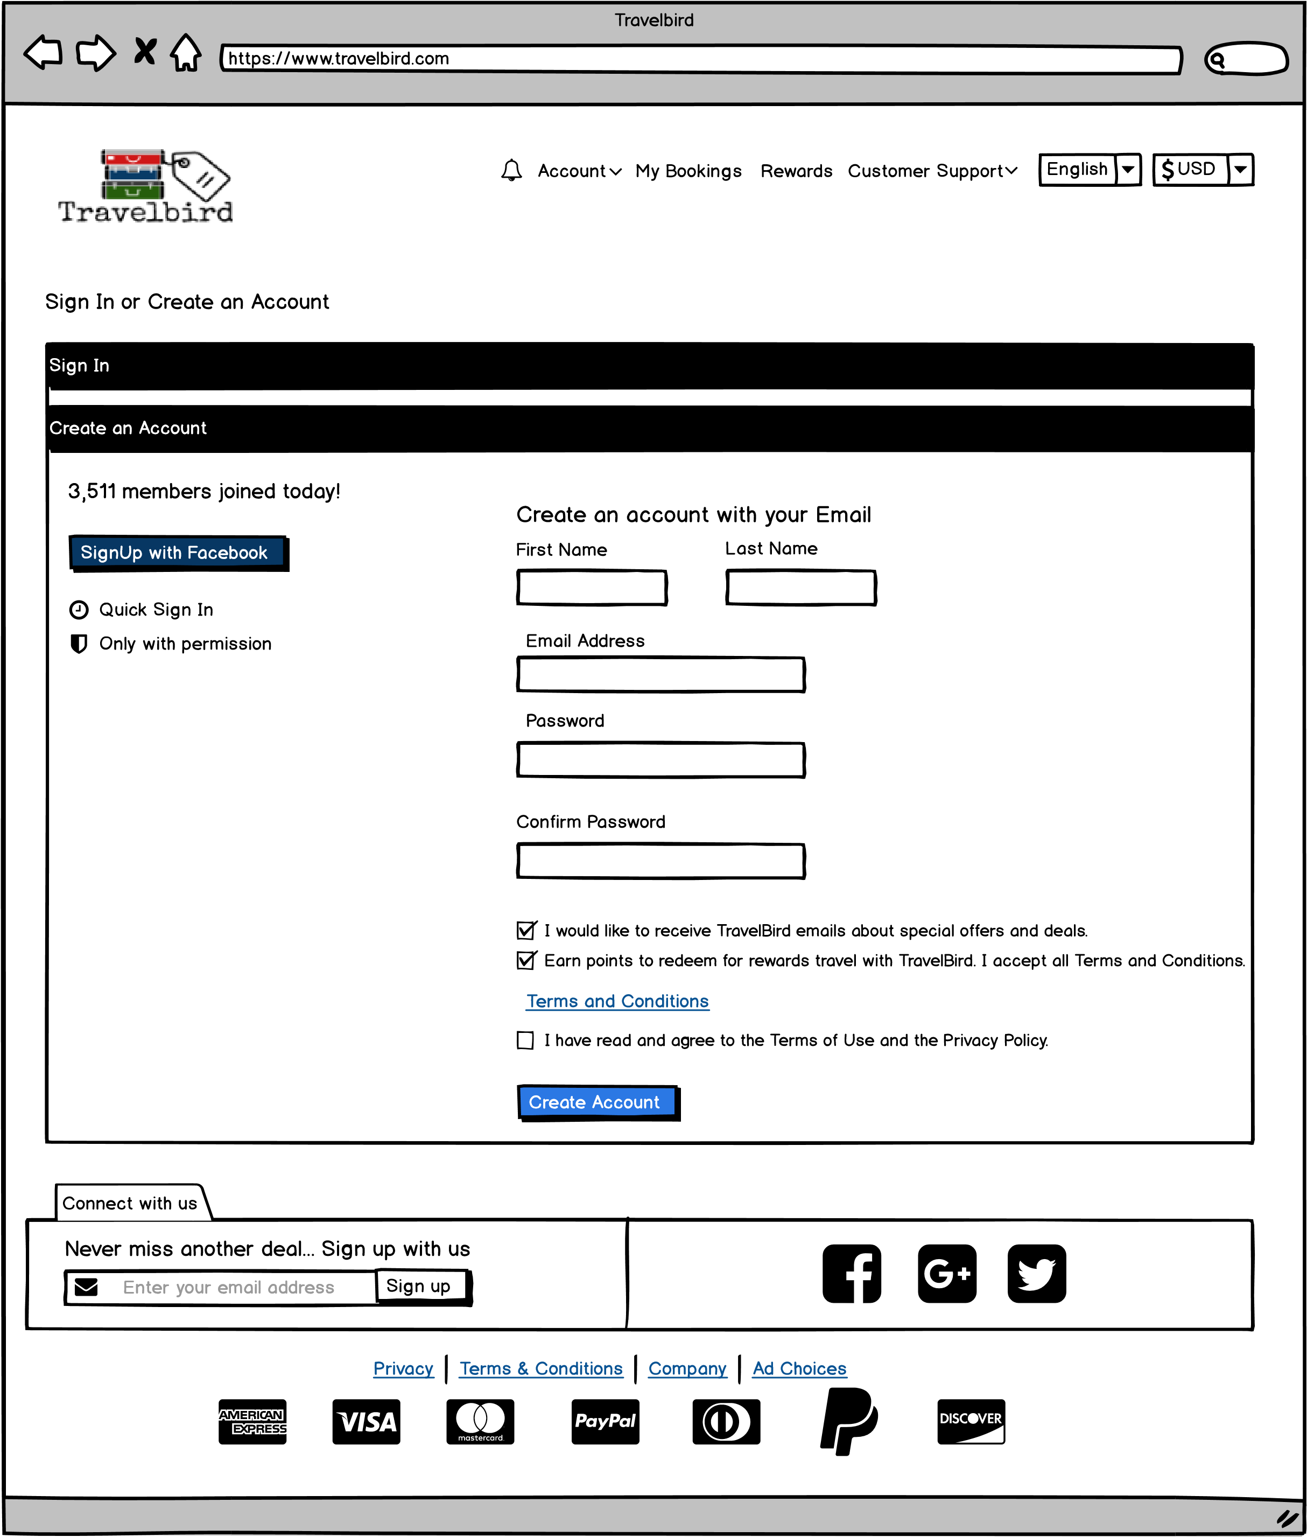



Check this box to confirm you have read the privacy policy and the click “create account” to enroll and move to the review and payment screen.

**2**



Complete this form field to create an account or use the “sign up with Facebook” button to authorize GoBoldly to pull your basic profile data to populate the fields.

**1**

**https://www.goboldly.com**

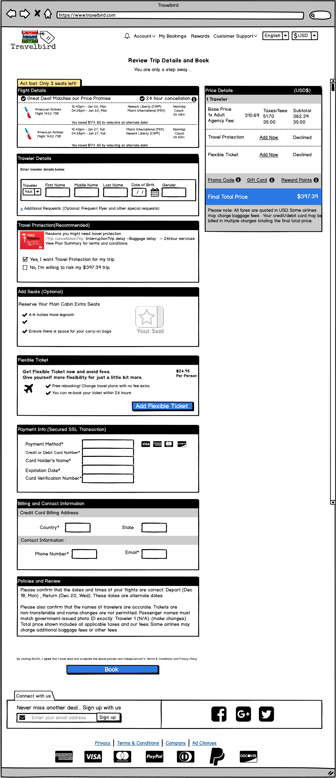

**https://www.goboldly.com**



Clicking here finalizes the transaction and moves the user back to the home page



Total amount owed plus options for adding flex tickets and travel protection. Links are also available to add a promo code, gift card or use rewards points. Clicking any of these options links will open a small pop-up form where the user can enter the code



The customer should enter their billing and contact information into this form.



Enter the credit card payment information into this form.



Choose to add a flexible ticket for an additional cost



Select or decline travel protection here. (Note that the total cost amount is added in the decline description line)



Enter the names, D.O.B. and gender for each passenger here.



Review your selected flight details here.

**8**

**7**

**6**

**5**

**4**

**3**

**2**

**1**

**https://www.goboldly.com**